19 october 2022,

I am trying to implement the pipetest example in mtest that is given on the following link:

https://tfel.sourceforge.net/mtest-python.html#the-mtest-class

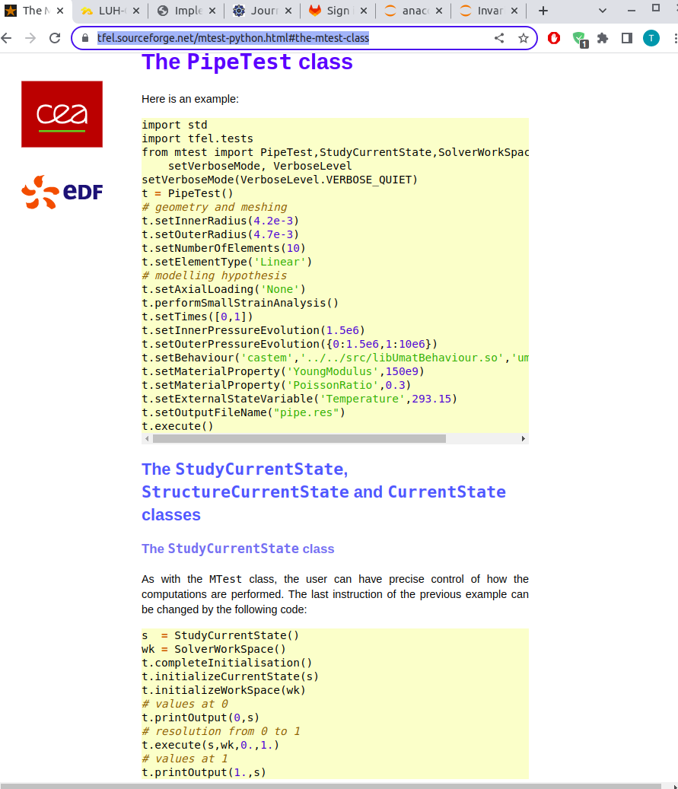
However, I keep getting errors when I try to import mfront in jupyter notebook.
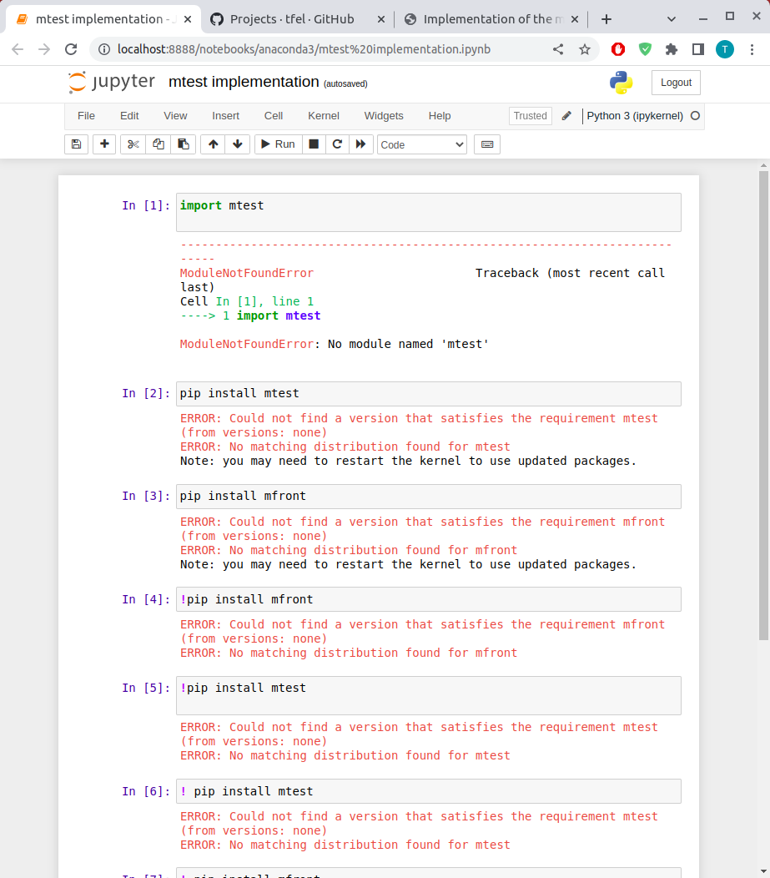
Now I am trying to figure out how to install and get rid of these errors. I tried looking for the guide in github but there are no instructions of how to install mfront and mtest in python.

1st november:

1- First error I got was "gcc_lib2.9.4 missing"
When I went to this path home/site packages/mtest/ _init-.py and ran this python file, I
got the above error.
This library .so was installed in usr/lib folder but it was fetched from anaconda3/lib.
One solution is to update this in usr/lib folder. But when I did this, it took too long and a
circle kept going round.
Second solution , I took this library from usr/lib to anaconda3/lib.
Then I shortcut linked using the command “ln” to link the libraries in anaconda3/lib and usr/lib.
From this, the init.py file imported the libraries. But there was a second error.
Error2: tfel didn’t import.
Here, I opened python in homesite packages/init_.py
however, python used in the base environment is installed in anaconda3/bin/

so I brought the sitepackages .so files to anaconda3/lib using the same shortcut links using the command “ln”

error 3

still tfel did not import.

I had python 3.10 installed in default location usr/local/bin. Then I opened 3.10 python and imported tfel but it did not import.

Error 4: Then I tried to build tfel again.

I checked the path in the bashrc file and the path was .local. I changed the path of python, and put path to anaconda3 python.
Then I had to “source” the bashrc file but again, import tfel didn’t work after doing these things.

Then I shutdown and restarted but due to messing with libraries in anaconda3 .so shortcuts, anaconda didn’t run in bash.

Then I deleted everything! Tfel, anaconda3, .local

installed anaconda3 again
downloaded tfel source again in downloads and followed the installation guide of spack using the commands git clone … from tfel.sourceforge.net

error 5 :

then there was error because of missing linux library. I did sudo apt and installed the library. It was something like Qt5Gui. Failed to find “GL/gl.h”

then forgot to run load command in spack but ran python 3.10 everywhere but import command didn’t work for tfel.

Then I went into spack/bin/spack/python

I ran this file, but still didn’t import

then wen to spack/opt/spack/linux_ubunt/gcc.11.3.0

I saw that there were libaries and there was python 3.9

I ran this and imported tfel but still didn’t work.

All these folders had bin and libs. I copied and pasted them all to a folder named combine and then went to combine’s bin folder and opened python and finally! Mtest imported!

Then I made a link for python 3.9 in the home folder and now that works but there are new challenges. However, the mfront works now. So its a success.

3rd november:

8th november:

Now using the tutorial on youtube, I found that I have to generate an mfront file first . Mfront generates a .so file and also an src folder. The command is mfront –obuild –interface=python filename.mfront.
This command I also found in the thomas helfer paper. This command gives interface error:

The commands in this picture I used to download the example files from github repository.
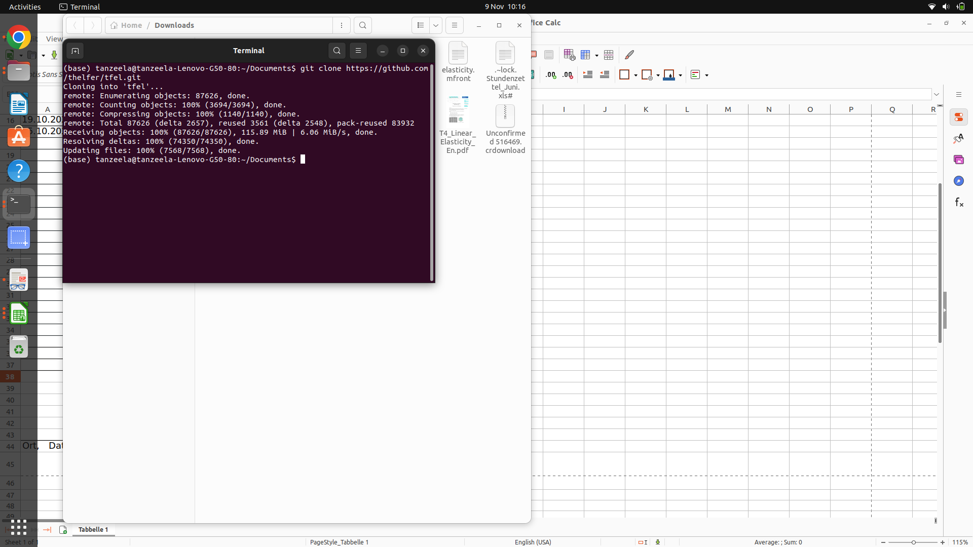

These commands I used to find the version of mfront installed

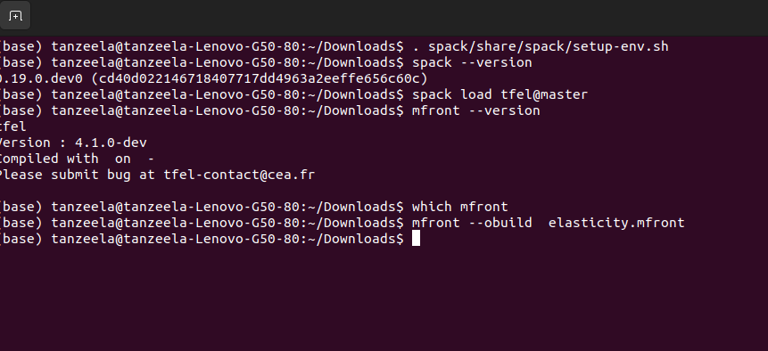
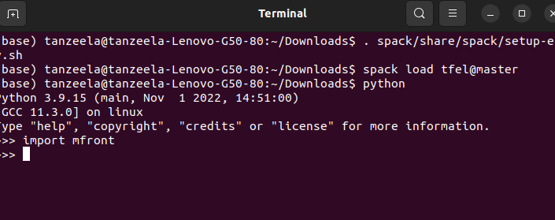

This commands spack are needed to bring the correct python to the path. These commands need to be run to add python and mfront to the path

I also found out that using python interface to build the .so files for mtest is not feasible . This I found in the issues ta in he github repositry.
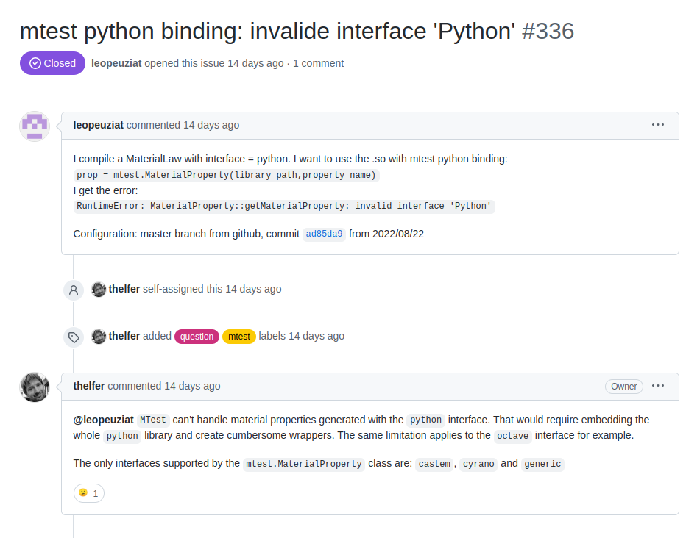
So I

When I tried to run the examples on these pages for my file , I get errors. I am using file elasticity.mfront in mfront to be converted into an so file.

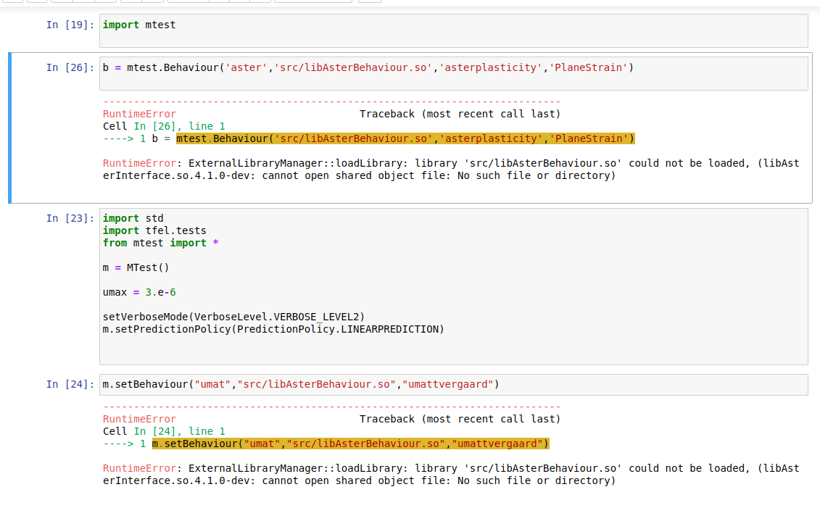

because I am using umat here as it is used in the example, so I tried to again generate the .so file using umat interface in the terminal. That gave this error. I am not sure why this is giving an error when I specify an interface. Inititally, when I gave an interface of aster, it generated a .so file of libasterbehaviour.so in a src folder.
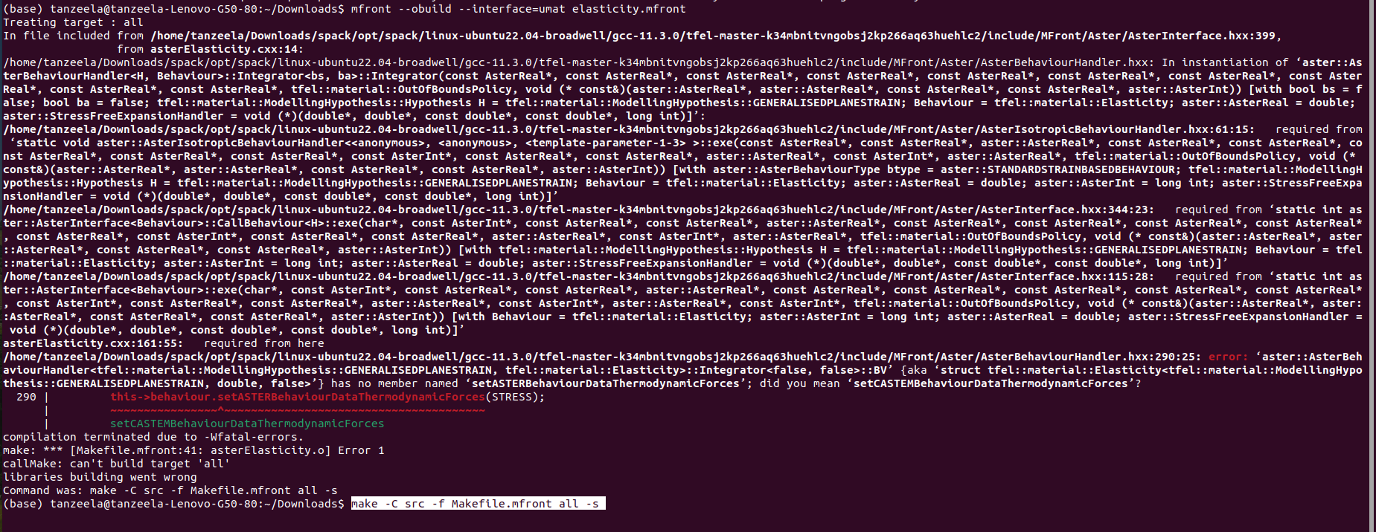

References:

https://tfel.sourceforge.net/mtest-python.html#the-mtest-class

https://thelfer.github.io/MFrontGallery/web/SemiImplicitModifiedCamClay_OpenGeoSys2020.html#implementation-into-mfront

https://joss.theoj.org/papers/10.21105/joss.02003

